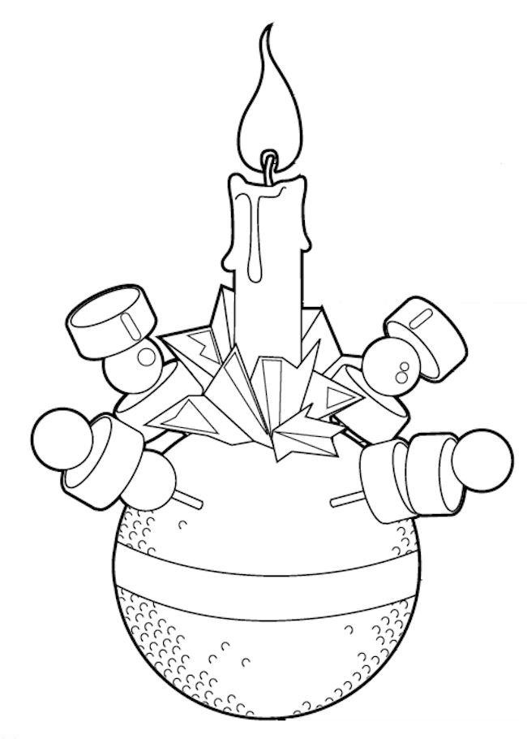

Holy Trinity Dunfermline wishes you a Merry Christmas!
Join us on YouTube search HolyTrinityDunfermline
at 4pm Wednesday 23rd for our Christingle

